3.76: a)
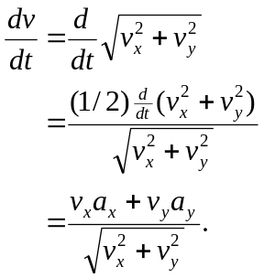
b) Using the numbers from Example 3.1 and 3.2,
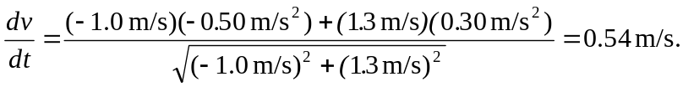
The acceleration is due to changing both the magnitude and direction of the velocity. If the direction of the velocity is changing, the magnitude of the acceleration is larger than the rate of change of speed. c) 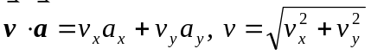, and so the above form for 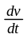 is seen to be 